|  |  |  |  |  |
| --- | --- | --- | --- | --- |
| |  | | --- | |  | |  | |  | |  | |
| TiltBot  Interactive maze-solving entertainment device. |
| FINAL SPRINT DATE: 12 June 2024  Jaime Martinez Coca - 1634495 Robert Pearson Ruiz – 1630916  Sergio López Parejo – 1634093  David Fuentes Insa - |

Table of Contents

Project description 1

Electronic components 1

Scheme 1

Extra components and 3D pieces 1

Foreseen risks and contingency plan 2

TiltBot

Interactive maze-solving entertainment device.

# Project description

TiltBot is an entertainment device where you try to get a ball from one side of a maze to the opposite side, just by tilting it. Along the way, you'll need to dodge holes, or you'll have to start over! Using it is simple: you can tilt the maze platform where the ball is located with a joystick.

If crossing the maze is too difficult, TiltBot has an extra feature. You can switch to an automatic mode, where AI will solve the maze, showing you one of the possible paths to the end. (For now, the algorithm is somewhat limited. See the Limitations section.)

Additionally, to increase the amount of fun, the maze format can be customized. You can open or close holes, as well as restructure the walls to choose your own difficulty.

# Electronic components

This is the list of the used components:

* *Arduino UNO R3*
* *Raspberrypi 3B+*
* *Joystick*
* *x2 Microservo*
* *Camera Raspberrypi v2*

*Scheme

* *Servo_1 SEL is connected to digital pin 6*
* *Servo_2 SEL is connected to digital pin 5*
* *Joystick SEL is connected to digital pin 2*
* *Joystick VER is connected to digital pin A0*
* *Joystick HOR is connected to digital pin A1*

# Extra components and 3D pieces

* *Labyrinth base*
* *Plugs*
* x4 exterior walls
* x4 exterior floor pieces
* x2 cross shaped walls
* x2 T shaped walls
* x2 I shaped walls

*- The labyrinth base is the main structure component, where the maze will be put together for it to be solved.*

*- The Plugs allow us to change the location of the holes, as well as modifying the difficulty of the maze, increasing or decreasing the number of wholes through which the ball can fall through.*

*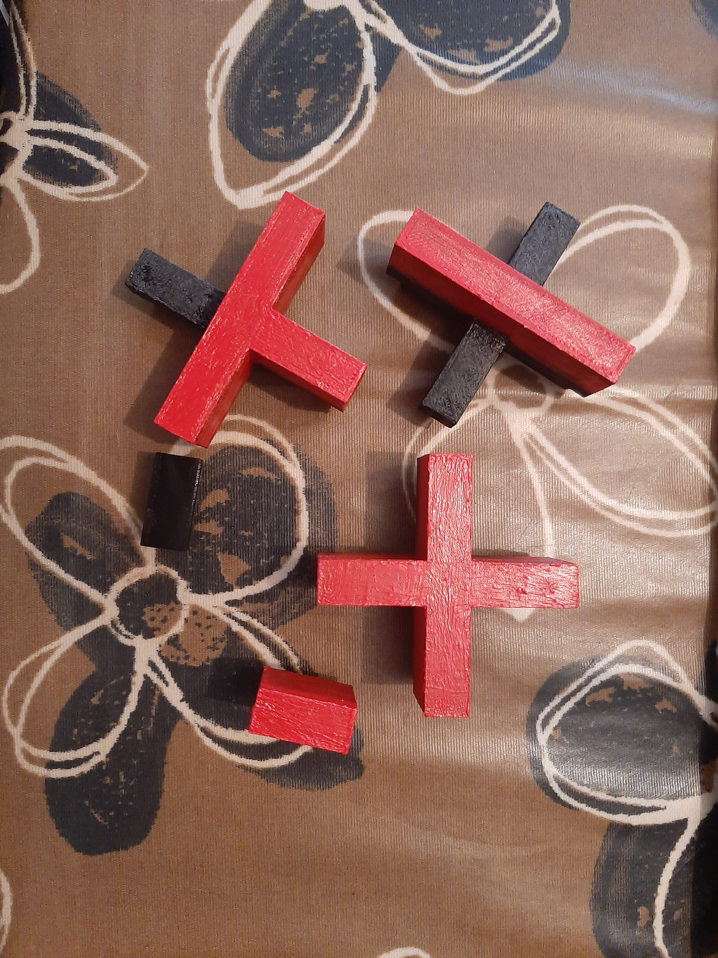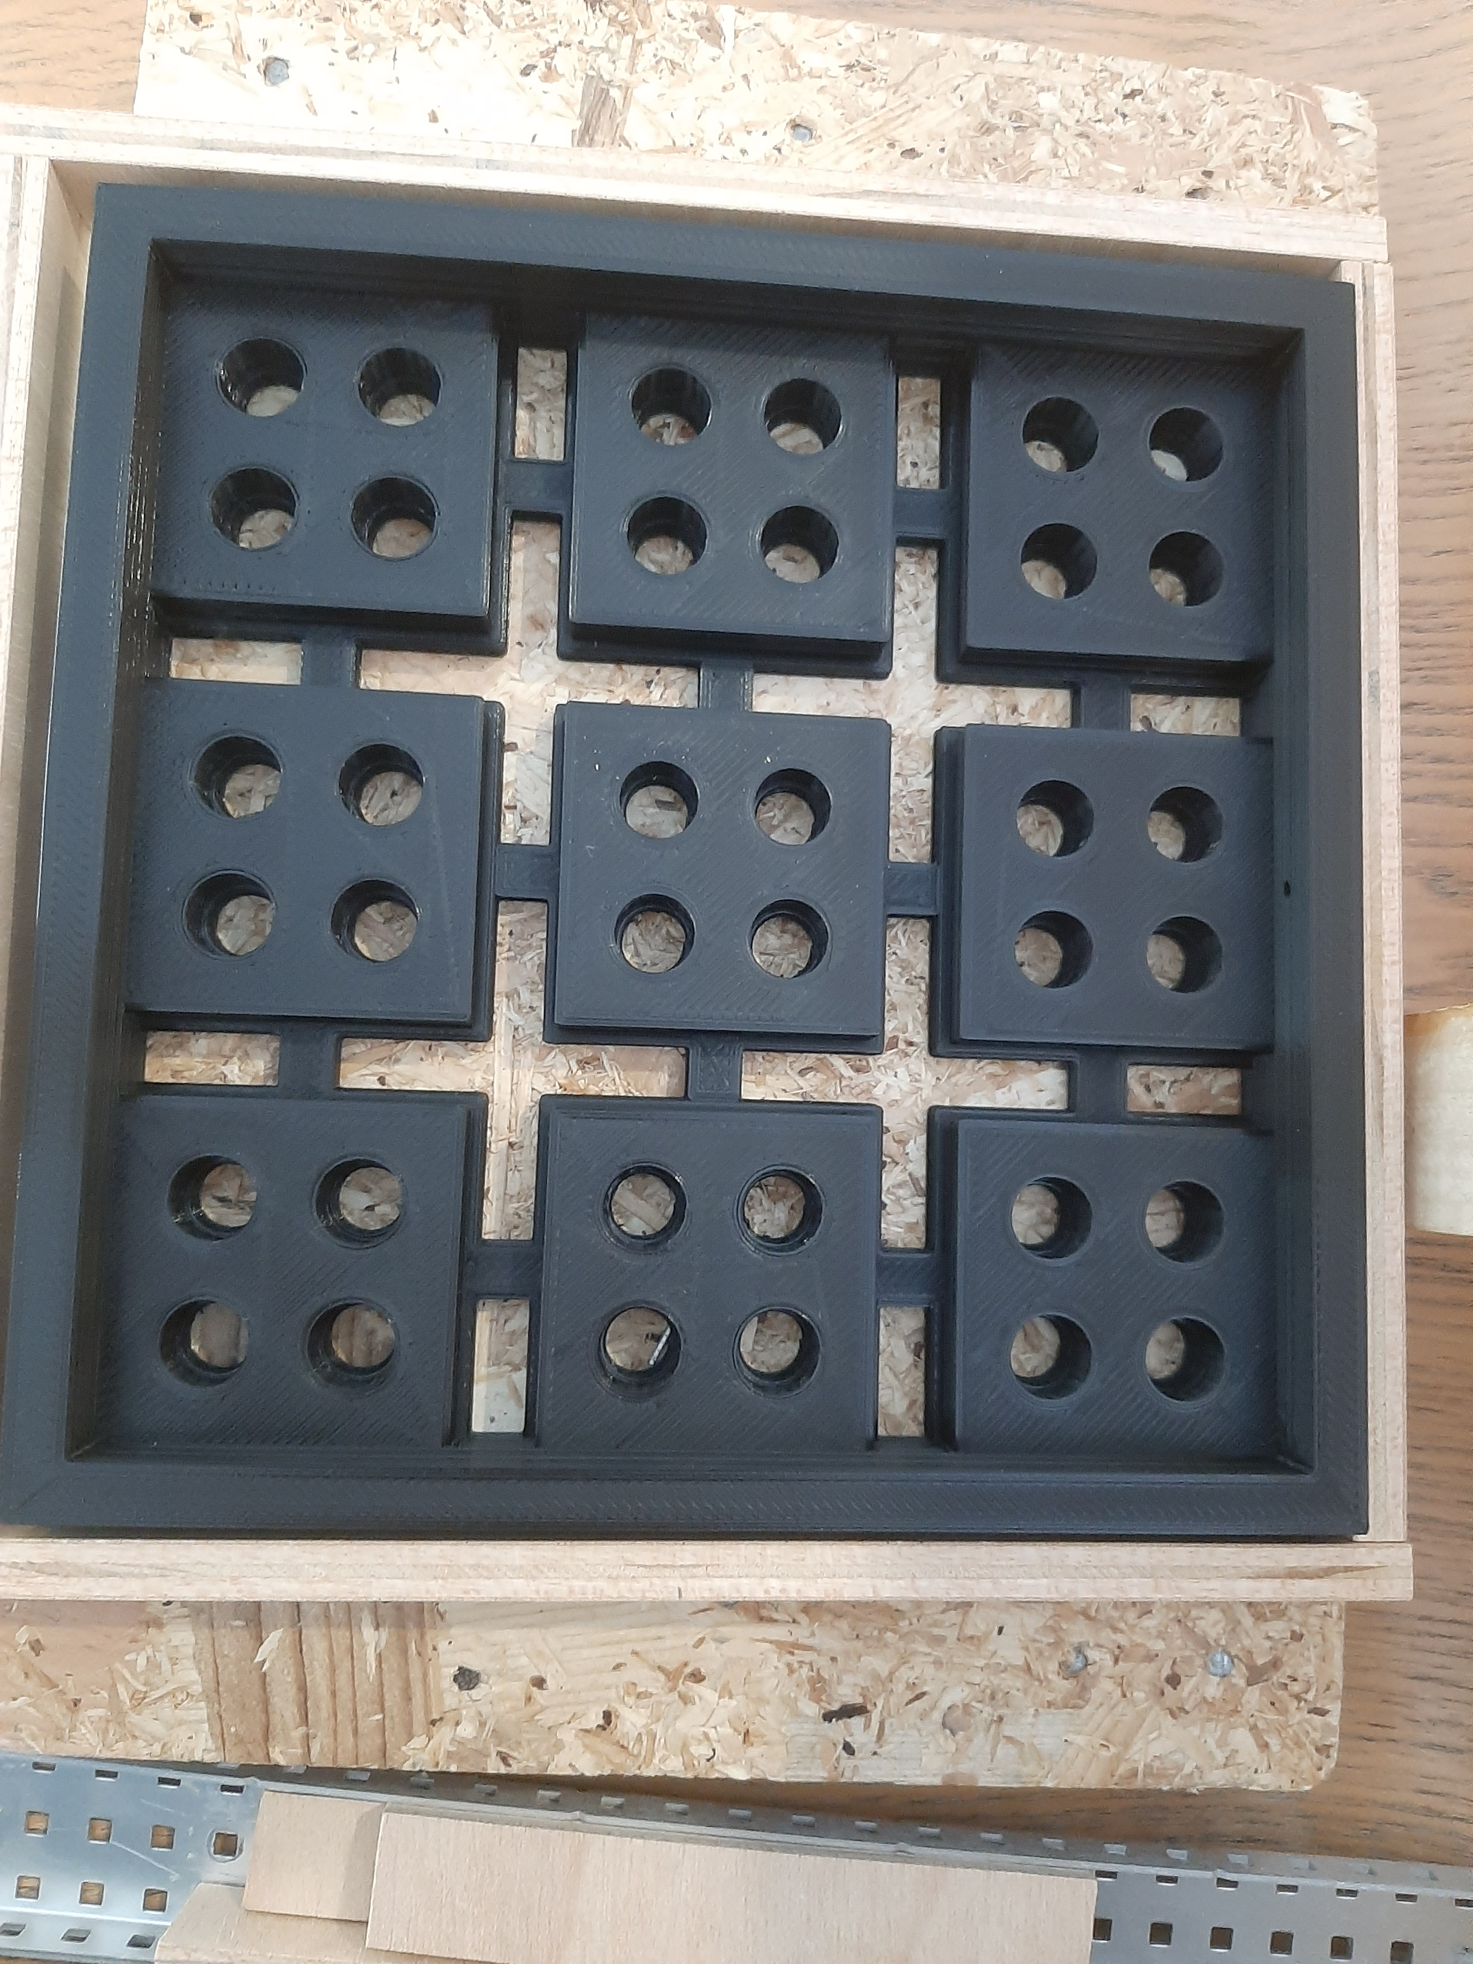- All the different types of walls and floors are also made so that we can change the shape and paths of the maze. Each piece has either floor, wall or both depending on the piece. On the one hand the floor parts are only as tall as the labyrinth base, so that the ball can go over these pieces without any struggle. On the other hand, the wall parts are made taller, so that the ball can not go pass them, giving the shape of the path that it needs to do in order to get to the end.*

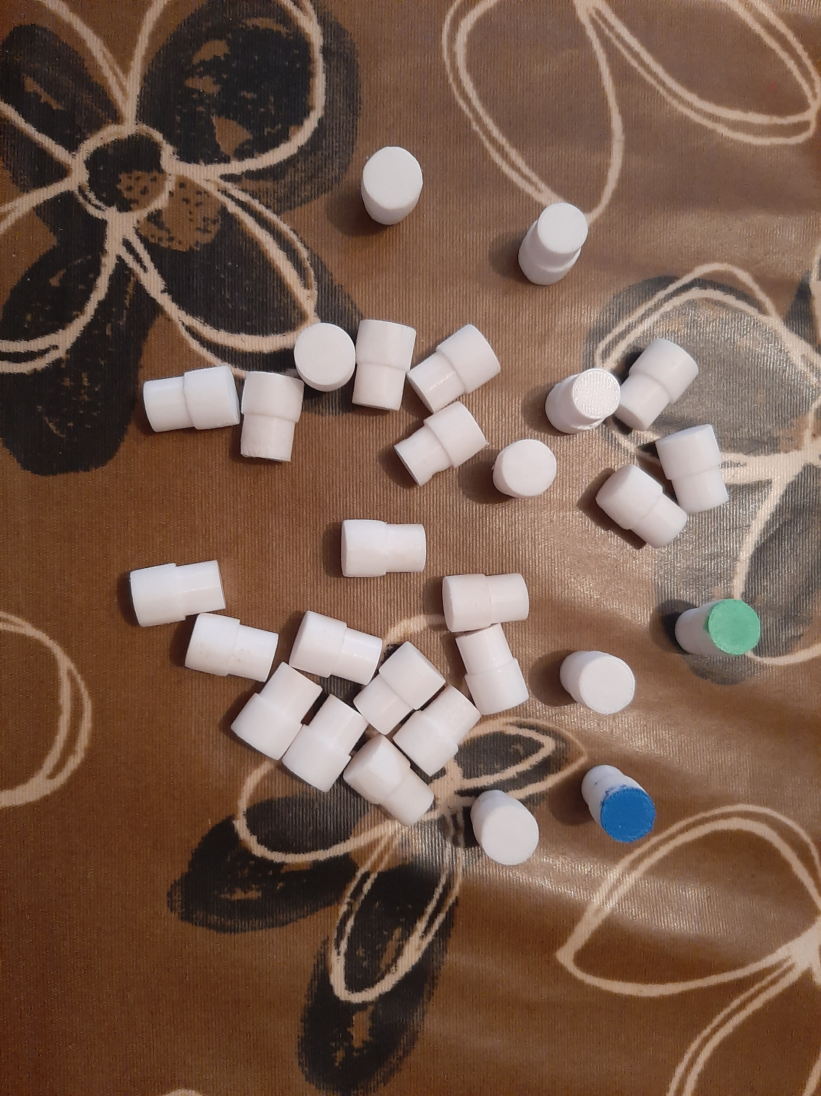

|  |  |  |  |  |
| --- | --- | --- | --- | --- |
| **Risk #** | **Description** | **Probability** (High/  Medium/  Low) | **Impact** (High/  Medium/  Low**)** | **Contingency plan** |
| 1 | La visión por computador no siempre resuelve el laberinto  (encuentra camino, pero la bola se desvía / no encuentra camino) | High | Medium | Perfección milimétrica de los materiales y mejora de la calidad de imagen. |

# Foreseen risks and contingency plan

References

This project has been inspired by the following Internet projects:

Original idea for the project by Antonio Álvarez: <https://www.youtube.com/watch?v=PMSr5L0SD24>

Tutorial - Usage of Joysticks with Arduino: <https://programarfacil.com/blog/arduino-blog/joystick-con-arduino/>

Tutorial - Usage of Servos with Arduino: <https://programarfacil.com/blog/arduino-blog/servomotor-con-arduino/>

Tutorial - Send data from Arduino to Raspberry (Serial connection): <https://www.youtube.com/watch?v=-3swby4ryU4>